**A Home Environment Monitoring Design on Arduino**

**ABSTRACT**

To keep abreast of home living environment, a home environment monitoring device based on Arduino was designed. With Arduino UNO hardware platform and various sensors to acquire the indoor temperature, humidity, light and combustible gas changes in real-time, then upload this to the monitoring platform, according to the collected data to adjust the surrounding environment. The test results show that the design can achieve the collection and stably upload of home environment data, and meet the design requirements of remotely monitoring the living environment conditions. The invention has follow advantages: low cost, small power consumption, simple structure and convenient installation.

Keywords-Environmental monitoring Arduino UNO; Smart; Sensor

**INTRODUCTION**

With the rapid development of information technology, human beings are facing the increasingly serious environmental threats while enjoying the convenience brought by information technology. Immediately, people began to pay attention to the home environment, and promptly improve the living condition for them to create a good living environment. In this paper, by existing mature sensing technology and Internet technology to obtain environmental status information in real-time, then make the appropriate adjustments, this design is simple and fast, low cost, high practicality. A home environment monitoring system Based on Arduino platform was designed to monitor temperature, humidity, light and combustible gas content changes in one day, upload the data to the server monitoring platform and check the current environmental status through the mobile phone APP or webpage platform. According to the monitoring information to remotely control the home environment,

For example: turn on the fan, turn on the humidifier and so on.

**EXISTING SYSTEM**

With the rapid development of science and economy, people’s pursuit of comfortable life becomes higher and higher, so smart home monitoring system comes into being. However, the cost of smart home is high at present; it is difficult for ordinary families to accept. But this existing system is complicated in connection and wiring and also for younger people and older people. And the cost of wiring and new device cost much more and not easy to operate.

**EXISTING SYSTEM DISADVANTAGE**

* Cost is high.
* Complicated circuit
* Complicated operation.
* Not easy for replacement

**PROPOSED SYSTEM**

It can be seen from the figure that the device is composed of the information acquisition module, the intermediate information processing module, the network transmission module, the smoke alarm module, the household appliance control module and the environmental status real-time monitoring platform. Information acquisition module is mainly used to collect the surrounding environmental information and the collected information to wired transmission to the main processing circuit module for processing. Information acquisition module uses a hybrid temperature and humidity sensor DHT11 to complete the collection of temperature and humidity, the choice of BH1750 light intensity sensor to collect the current light conditions, with MQ2 sensor to detect the concentration of combustible gases. The smoke alarm module consists of a speaker and a red LED indicator. When the sensor detects the presence of flammable gas around, the speaker will make a sound, while the LED light, and remind the user of gas leaks. Main control circuit ATMEGA 328P model of the microcontroller, the sensor information collected after processing, sent through the network module to Internet of Things monitoring platform up. Then send the control instruction to the main processor, control the working condition of the household electrical appliance]. In addition, the main control circuit module also analyzes the information collected by the smoke sensor to complete the smoke alarm. The alarm circuit consists of a speaker and red LED lights. When the smoke sensor detects the increase of combustible gas content in the home, it will trigger the smoke alarm circuit. When the alarm sounds, the speaker will emit a fixed frequency sound, meanwhile the LED will send a red alarm to remind the user of smoke leakage. Figure 3 for the smoke alarm circuit and Arduino U140 board connection circuit diagram, with the Arduino D3 mouth speaker control, D6 mouth control LED lights. This design can not only realize the remote real-time monitoring of indoor environmental conditions, but also through the mobile phone client to control indoor appliances. When the indoor temperature is monitored too high, the indoor air conditioner is remotely cooled down by the mobile phone; when the indoor humidity is too low, the humidifier is turned on to humidify the room through the mobile phone; when the indoor light is too dark, the room is opened by the mobile phone light. Circuit design is through the main processor control relay work.

**PROPOSED SYSTEM ADVANTAGE**

* Easy to operate.
* Cost effective.
* Easy to install
* Easy to monitor and control.

**BLOCK DIAGRAM**

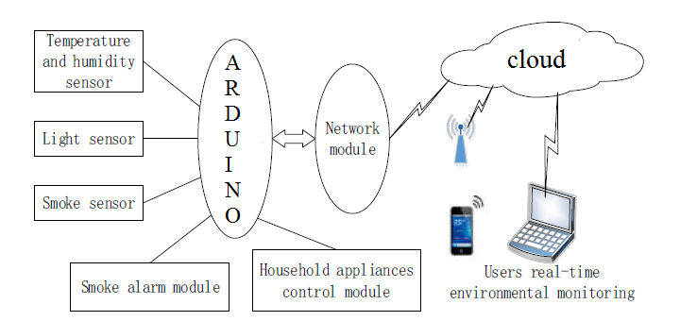

**HARDWARE REQUIREMENT**

* Arduino
* Light sensor
* Temperature sensor
* Smoke sensor
* Relay
* GSM/GPRS

**SOFTWARE REQUIREMENT**

* Arduino IDE